Military influencers and open-source reporting on the war in Ukraine: The case of the Institute for the Study of War

Abstract
This article investigates how military influencers shape open-source intelligence (OSINT) reporting on the war in Ukraine through the Institute for the Study of War’s (ISW) Russian Offensive Campaign Assessments. We analyze a dataset of 170,236 hyperlinks scraped from 1,145 ISW daily updates between February 2022 and April 2025 and map the ways different types of influencers from different countries and on different platforms are cited. The results reveal substantial asymmetries in these citation patterns. Russian accounts are cited around 60% more often than Ukrainian ones and overwhelmingly (over 90%) originate from Telegram, whereas Ukrainian sources are dominated by official government and military institutions, most notably the Ukrainian General Staff’s Facebook page. Chi-squared analyses confirm strong dependencies between nationality, platform, and publisher type. ISW relies largely on independent Russian bloggers on Telegram for information about developments on the Russian side of the frontline, while Ukrainian updates draw mainly on institutional and official sources. Russian sources appear particularly often in the political sections of the reports, where they are more likely to be used as examples of statements or narratives to be interpreted rather than as direct evidence of battlefield events. The study identifies ISW as a central translator of open-source material from military influencers into information usable by mainstream media. More broadly, the findings illustrate how the media ecology of contemporary warfare combines official communication, journalistic reporting, independent online commentary, and social media platforms such as Telegram and Facebook. Governments, military officials, and mainstream media remain influential as long as they are perceived as credible and useful—but when that trust erodes, independent military influencers take their place.

Introduction
A growing body of literature explores how modern information technology, particularly social media platforms and smartphones, reshapes the relationship between the public and the battlefield in contemporary armed conflicts (Merrin 2019; Merrin and Hoskins 2020; Norman et al. 2024). By enabling warriors to publish directly to a global audience, independently of conventional editorial media, the news flow has been fundamentally disrupted (Bowd 2016; Wall 2005). The consequences have been theorized as arrested war (Hoskins and O’Loughlin 2015), radical war (Ford and Hoskins 2022), digitally witnessable war (Bareikytė and Makhortykh 2024), and participative war (Merrin 2019). Ford and Hoskins (2022, 10) even posit that the emergence of the smartphone and social media has changed the very nature of warfare to an extent that challenges the fundamental teachings of Clausewitz. In a new media ecology with blurred lines between civilians and combatants, everyone can participate in activities related to war fighting through their mobile devices. This has given rise to a new species of online opinion makers: the military influencer (Divon and Eriksson Krutrök 2025; Kalnes and Bjørge 2025).
In this article, we investigate how military influencers are used as sources for open-source intelligence reporting on the war in Ukraine. We focus specifically on the daily updates — formally known as the Russian Offensive Campaign Assessments — by the Institute for the Study of War (ISW) as a paradigmatic case. ISW has been highly cited by mainstream media in the West throughout the war and makes extensive use of both Russian and Ukrainian social media accounts as sources. The daily updates thus constitute one of the key mediators through which reporting by military influencers finds its way into reporting by mainstream media.
Overall, we find that being cited as a source by the ISW depends very significantly on the type of military influencers we are talking about, their nationality, and the platform they publish on. Russian sources are cited 60% more than Ukrainian sources and 90% of them are published on Telegram. We know that Telegram is the most used social media platform in both Ukraine and Russia (Bareikytė et al. 2024). Despite its Russian origin, Telegram is generally seen as a useful platform for citizens, politicians, and government agencies in Ukraine (Özdemir 2023; Bareikytė et al. 2024). The reason is that Telegram offers publishers a high degree of control over the content on their channel and gives them the ability to create a shared user experience for all readers. Telegram does not have a recommender algorithm, nor does it mix posts from different channels in the user's timeline. Instead, each channel can be compared to a blog, in the sense that users will only see posts from that channel in chronological order when they visit.
Accordingly, Telegram has been used to study the war coverage of Ukrainian and Russian news agencies (Ptaszek et al. 2024), cyber resistance among Ukrainian activists (Canevez et al. 2024), concerns of citizens under Russian occupation (Bareikytė and Makhortykh 2024; Lokot 2023), wartime communication from Ukraine’s intelligence agencies (Schrijver 2025), and the emergence of military bloggers (Hoskins and Shchelin 2023; Özdemir 2023). However, the fact that Telegram is widely used does not necessarily mean that it is also widely trusted as a source in open-source reporting. It is not the only platform used by military influencers in relation to the war in Ukraine, which makes it interesting to investigate how sources on Telegram are cited compared to sources on other platforms.
Platforms like Facebook and Twitter/X are very different in their use of recommender systems, algorithms that shape the user experience, and they are not generally popular in either Ukraine or Russia. Facebook has some reach in Ukraine, but Twitter/X is rarely used. Furthermore, both Facebook and Twitter/X have been banned in Russia since shortly after the full-scale invasion in 2022 (Milmo 2022). When Ukrainians and Russians communicate on Facebook and Twitter/X, they therefore typically have a Western audience in mind. In this sense, the present study advances our understanding of the complex relationship between traditional mainstream media and social media influencers on various platforms (Hoskins and O’Loughlin 2015; Wasike 2025).

Assumptions
We work from the assumption that the ISW functions as a curator of information between social media influencers and mainstream media (Kallioniemi 2021). If a particular channel is regularly cited by the ISW, then the information from that channel is likely to influence reporting in mainstream media.
ISW has published its daily reports since the very first days of Russia's full-scale invasion of Ukraine. These include extensive footnotes with links to the sources on which the assessments are based. More than 85% of those links are to posts on social media with Telegram as the most prominent platform. The daily reports have been widely cited in mainstream media across the world. For example, a search through the Danish media monitoring service Infomedia in June 2025 revealed that ISW had been cited in more than 4,000 news articles since the full-scale invasion in 2022. Studying the sources that ISW uses can therefore, we posit, contribute to our understanding of who the military influencers are and how they gain prominence.

Hypotheses
Our null hypothesis is that there is no systematic difference in how often different sources are cited by the ISW. Any variation in citation frequency should be random. Our first alternative hypothesis (H1) is that Telegram, as a platform, plays a more important role in reporting from the Russian side of the conflict. Russian links will therefore, more than Ukrainian ones, tend to be to Telegram channels. This follows from the fact that Ukrainians have access to a range of social media platforms that are banned in Russia. Ukrainian military influencers have access to Facebook, Bluesky, X, TikTok, and so forth, all of which could be cited by the ISW. Russian influencers, on the other hand, have a more limited choice with Telegram as the most popular platform in the country, followed by VKontakte (Statista 2025).
Our second alternative hypothesis is that independent channels are more likely to be cited (H2a). Social media makes it easier for independent publishers to reach their audience, which gives a news curator such as ISW direct access to sources and offers an alternative to traditional reliance on mainstream media or statements from government sources. We also investigate country-specific differences. In particular, we hypothesize that the ISW is more likely to rely on independent social media channels when it comes to Russian sources, while being more inclined to use official government sources or mainstream media for the Ukrainian perspective (H2b). This would make sense given concerns about the validity of information from official Russian sources (Lai et al. 2024).
Our third alternative hypothesis is that different sources are used for different purposes (H3). The ISW daily updates are divided into sections with each their focus. Typically, the first part is about political developments and high-level military-strategic discussions, whereas the last part focuses on tactical military developments along the front line. It would make sense that different platforms are used as sources of information for these different sections (H3a), as they fundamentally differ in the demands for information required to compile and analyze each section. For example, in the political section it might make sense to link to polemic exaggerations as examples of nuclear saber-rattling, but in the military section it is primarily relevant to link to perceived accurate information that can be used to update the map of the frontline. These types of information may be available on different platforms. Likewise, it seems reasonable that different types of military influencers would be cited for different purposes and were therefore also distributed differently across the sections (H3b).
Finally, we address the question of trustworthiness. During the war in Ukraine, there has been much debate about Russian misinformation and how social media is leveraged to promote pro-Russian narratives in more or less transparent ways (Bösch and Divon 2024; Oleinik and Paniotto 2024; Santos Okholm 2025). We explore what the data can tell us about how ISW assesses the reliability of Russian channels and whether they are not used as trustworthy sources of information, but rather as examples of misinformation or political statements to be analyzed (H4).

Empirical data and methods

Data collection
We collected the daily updates from the ISW website ( https://understandingwar.org) from the beginning of the full-scale invasion in February 2022 until our cutoff point on the 28th of April 2025. The first update available in HTML is from February 28th, four days into the war. There have been 10 days without an update due to various holidays. This leaves us with 1,145 daily updates spanning a period of 1,155 days.
We used a custom-built web scraper (a Python script using the Requests and BeautifulSoup libraries) to collect the HTML for each daily update and parse the hyperlinks. Sources are linked in footnotes and a hyperlink thus works as a proxy for a cited source. Typically, there will be between 70 and 100 footnotes, and each footnote can contain multiple outgoing links to different sources that are related to the same piece of information. Since we were not interested in the situations where the ISW cites their own prior work, we excluded all links to understandingwar.org and isw.pub (the ISW websites). This provides a total of 170,236 outgoing links from the ISW daily updates for the period in question. 94,482 of these links are unique (some sources are linked more than once).
Each update is organized into different sections. They typically begin with an overview of the most important political and high-level military developments, which ends with a bullet list of key takeaways. After that, there are in-depth views on events in different sectors along the front line.

Platform overview
Overall, Telegram is by far the most cited platform in the ISW daily updates. 59% of all links and 74% of unique links are to Telegram channels (see Figure 1). This was not the case in the first months of the war, where Twitter and Facebook were dominant, but it has been stably the case since June 2022. The fact that Telegram has a bigger share of unique links, meaning that Telegram posts are less likely to be cited more than once by the ISW, also indicates that the platform plays a bigger role as a source of latest news; it contributes relatively more with new sources to the daily updates than the other platforms do.
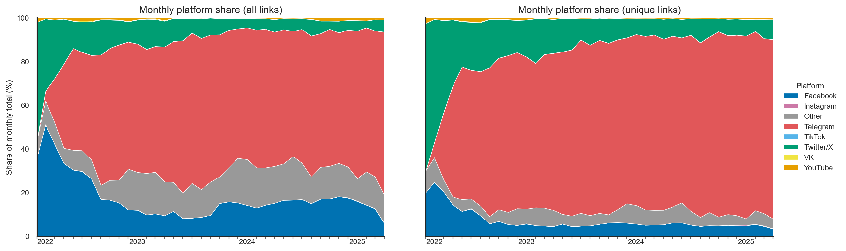
Figure 1 Daily distribution of sources from different media platforms as a percentage of all sources cited in the daily update. All sources (left) vs. unique sources (right).

Classification of influential publishers
Since we are interested in social media influencers, we proceeded to first rank individual publishers by their importance for ISW reporting and then classify the most influential publishers for further analysis. Many publishers have only been cited a few times and can thus be said to be of marginal importance in terms of influencing the content of the daily updates. We considered whether to use unique links or links in total as our measure of importance and eventually opted for a threshold of minimum 50 links. Due to different styles across publishers, where some make long and comprehensive posts covering multiple topics and others split the same amount of information into multiple posts, and due to the fact that these differences are obviously platform specific (short posts on Twitter/X vs. possibility for longer posts on Facebook or Telegram, for example) we decided against unique links.
The threshold for publisher importance reduces the number of publishers to be classified from 4,864 to 262, which means that about 5% of the publishers are retained for further analysis (see Table 1). However, these publishers are responsible for 83.2% of the total cited sources in the dataset, which speaks to their importance. VK and YouTube were excluded from the dataset because the format of the links in the ISW daily updates did not allow for automated identification of the channels behind the posts, and the number of references to those platforms was so small that it was considered unnecessary to do it manually.
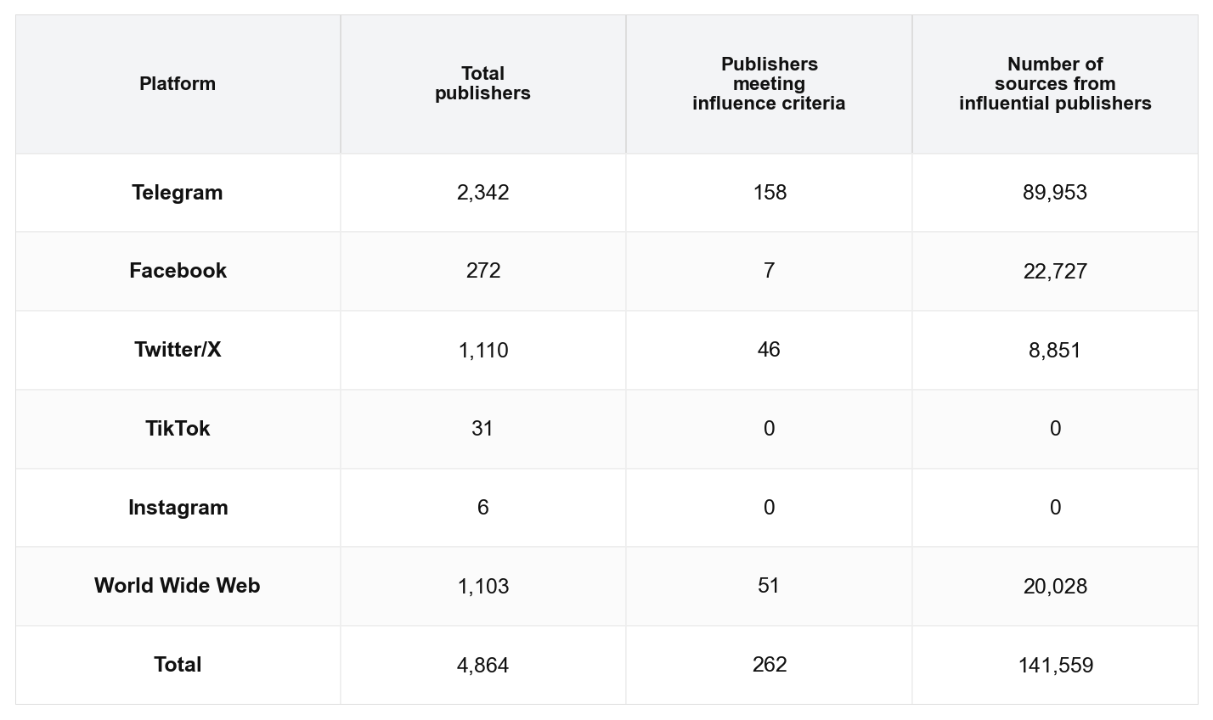
Table 1 Filtering by influence. Publishers cited more than 50 times in the ISW daily updates are retained.
Among the retained influential publishers, the lowest ranked is the Telegram channel of the Russian Movement of Strelkov, which is linked as a source 50 times across 20 different daily updates. At the other end of the spectrum, the highest ranked publisher is the Facebook page of the Ukrainian General Staff with 21,604 citations, which gives an average of almost 19 links per day.
As can be seen, no accounts on TikTok or Instagram surpassed the threshold of being considered an influential publisher in this study. This means the included platforms were Telegram, Facebook, Twitter/X, and the World Wide Web. The World Wide Web is of course not a social media platform, as such. The category in principle covers any kind of non-platfom website but in practice, for our study, this is typically websites of news organizations or state agencies.
To support further analysis, we manually classified the 262 influential publishers by nationality and type. The classification was done by one of the authors who speaks Russian and has a working understanding of Ukrainian.
Most publishers are either Russian or Ukrainian, but other nationalities also appear in the list, such as Belarus and the United Kingdom. The question of how to classify the occupied territories in Ukraine demanded some consideration. For these areas, we decided to classify pro-Russian views as Russian and pro-Ukrainian views as Ukrainian. Another edge case concerned Russian opposition media currently operating from exile. Here, it was decided to include them in the statistics as a Russian source. This left us with three classifications for nationality, namely Russian, Ukrainian and Other.
We also classified the channels by their type using the following categories: Mainstream media, Government institution, Military institution, Politician personal account, Military personal account, and Independent publisher. The first three indicate that it is a larger organization behind the channel, whereas the last three indicate that it is personally driven or at least a small group of people running the channel. The full list of influential publishers, as well as their classifications, can be seen in Appendix 1.

Different sections of the daily updates
As a final step in the process, we investigated whether different platforms and publishers were used as sources for different purposes in the daily updates. The format of the daily updates has evolved throughout the war, but since April 2023, they have been consistently structured such that there is a general section in the beginning with the most important military and political developments. This introductory section ends with a bullet list of key takeaways. After the key takeaways, the ISW report goes through different sectors on the front line in detail and provides map updates on which side controls which territory.
The key takeaways summary, therefore, provides a functional dividing line between the political part of the update and the part that focuses on military background information with map updates and tactical developments on the front line. Separating the footnotes used before and after the key takeaways section, we thus classified all sources from influential publishers based on whether they were used to support reporting on political events or tactical reporting on front-line developments.

Hypotheses testing
To explore our hypotheses we perform a series of chi-squared tests for independence (Gill 2017; McHugh 2013). Specifically, we evaluate the dependence of the nationality variable (‘Ukrainian’, ‘Russian’, ‘Other’) versus the platform (‘Facebook’, ‘Telegram’, etc.) and publisher type (‘military institution’, ‘mainstream media’, etc.) variables, both for sources found anywhere in the ISW reports as well as for sources found in the political and military sections respectively before and after the key takeaways divider. Further, we evaluate the dependence of the nationality versus the platform variable with both the full version of the dataset and a version excluding the profile of the Ukrainian General Staff on Facebook. The reason for doing that is that this particular Facebook account is disproportionately large compared to all other publishers in the study, and we wanted to test whether it skewed the results by hiding patters in the platform distribution for the other sources. Finally, we evaluate the dependence between location of links in the political and military sections versus the country.
Chi-squared determines whether the observed frequencies for two variables differ significantly from what would be expected if the variables were independent. For each of the above eight tests we produce a confusion matrix with the observed frequencies for all combinations of categories for the two variables in question. We then implement chi-squared as:
$$χ^{2} =\sum_{ }^{ }{\frac{{\left(O_{ij}-E_{ij}\right)}^{2}}{E_{ij}}}$$
Where O_{ij} is the observed frequency for the cell at row i and column j, and E_{ij} is the expected frequency for that cell. The expected frequency is found by dividing the product of the sums of observed frequencies for row i and column j with the sum of all observed frequencies. The expected frequency thus reflects what we should find if the distribution across categories was random. For example, in our case, if the nationality and source type variables were independent, we would expect the fact that military bloggers are Russian, Ukrainian or from a third country to make no difference to their chances of being cited as sources in the ISW daily updates. These are the expected frequencies. Chi-squared tells us how much the frequencies that we actually observe differ from those expectations. To know if the difference is statistically significant, we compute a P-value, which gives us the probability that the observed frequencies differ to the degree that they do from the frequencies we should expect if the two variables were independent.
For all eight tests we get P-values of 0.0000 indicating that the variables in question are highly dependent. In other words, on an overall level, the chances that Russian or Ukrainian sources get cited in the ISW reports depends greatly and not in the same way on their type and the platforms they are found on.
To explore our hypotheses further, we investigate how the individual categories drive this dependence. We do so by computing the standardized residuals for each cell in the confusion matrix. Standardized residuals measure the difference between the expected frequency and the observed frequency standardized by the square root of the expected frequency. They allow us to compare the contribution of individual cells to the overall chi-squared score, i.e. to the dependence of the variables in question, and understand the direction of this contribution, i.e. whether the dependence is due to the fact that the observed frequency is higher or lower than the expected frequency. For example, when we explore the dependence between nationality and publisher type in this way, we learn that it is mainly driven by the fact that military institutions are way more likely to be cited as ISW sources if they are Ukrainian (172.2 standard residuals above what we should expect if it was random) than if they are Russian (116.0 standard residuals below what we should expect). The threshold for notable deviations in standardized residuals is conventionally considered to be 2. Extreme values of the kind we observe could be due to small sample sizes and expected values below 5. This would invalidate the test, but we do not have that issue in the data. We therefore conclude that the variables in question are simply extremely dependent and conduct our analysis from there.

Limitations
This study is, first and foremost, an investigation into what can be said about social media platforms and military influencers based on a quantitative study of the citations by the ISW. It does not include a qualitative reading of the daily updates where the citations are used. Such an approach could provide a different perspective, but it is beyond the scope of this paper.

Results

H1: Platforms vs. country
In general, ISW cites Russian sources more than Ukrainian ones. 57% of all links in the daily reports are to Russian sources compared to 35% to Ukrainian sources. ISW also cites Telegram more than other platforms, with Telegram accounting for 64% of all links in the daily updates.
As shown in Table 2, this focus on Telegram is overwhelmingly associated with Russian sources. Indeed, 90.3% of all links to Russian publishers in ISW’s daily reports are links to Telegram, which is a very high overrepresentation compared to Ukrainian and other publishers (r=+95.3). This supports our first hypothesis that Telegram, as a platform, plays a more important role in ISW's reporting from the Russian side of the conflict than it does for the Ukrainian side.
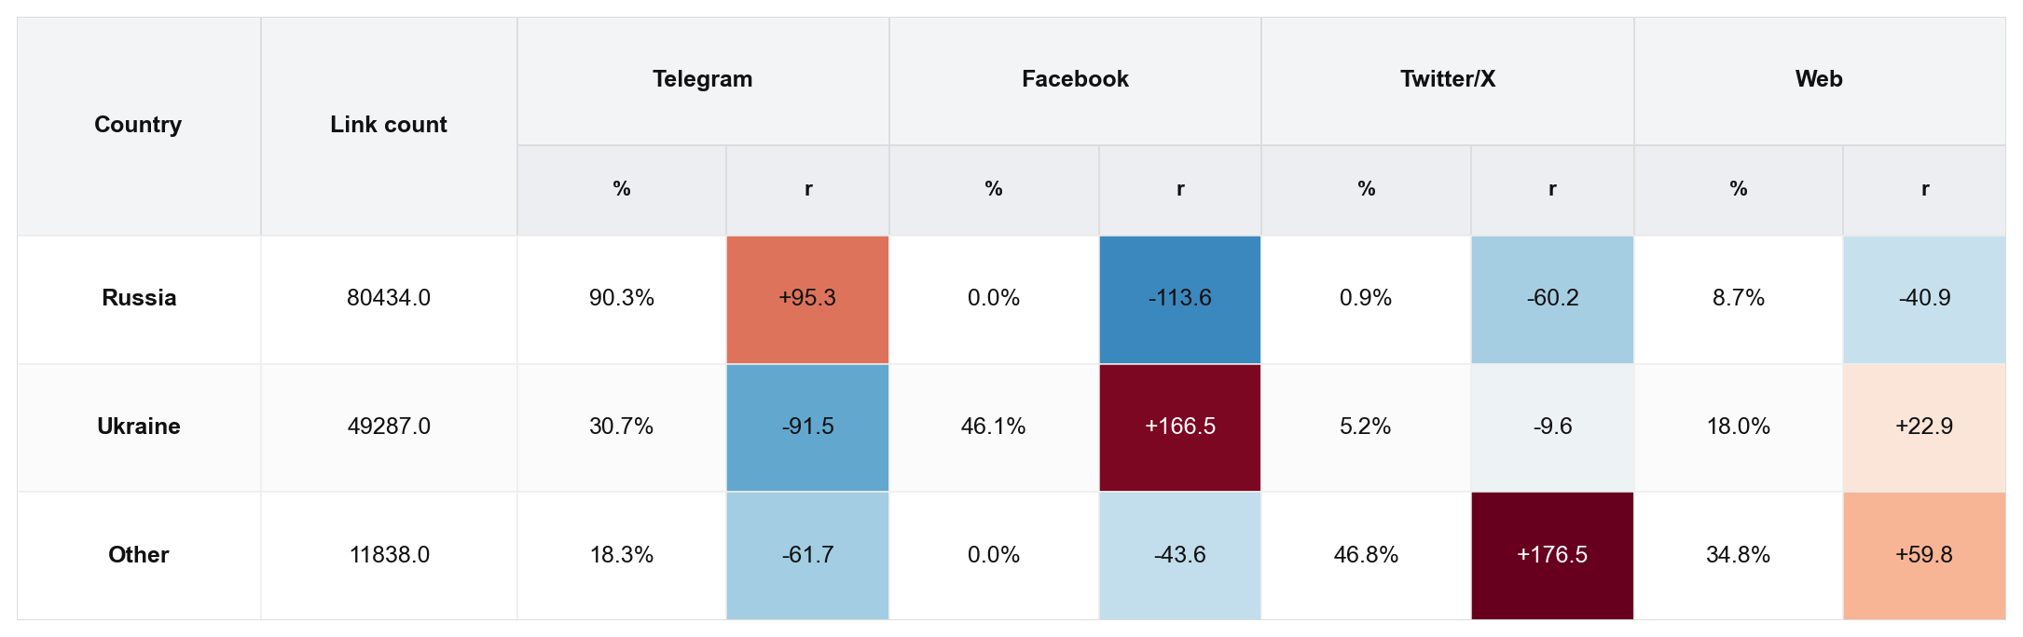
Table 2 Country vs. platform. The platform's proportional share of the total number of links for each country (%) and the difference between observed and expected values measured in standardized residuals (r).
This is further supported by the fact that Telegram is not as dominant a platform for ISW’s reporting on the Ukrainian perspective. Ukrainian sources are most likely from a single publisher on Facebook, namely the Ukrainian General Staff. This Facebook account alone is responsible for 43.8% of all citations of Ukrainian sources, and that brings Facebook as a platform to 46.1% of the total number of Ukrainian links. Compared to Russia and other countries this leaves Facebook vastly overrepresented (r=+166.5) for Ukraine and Telegram very underrepresented (r=-91.5) compared to Russia, although Telegram still accounts for 30.7% of the total cited Ukrainian sources. International sources that are neither Russian nor Ukrainian are likely to be Twitter/X accounts (46.8%) or websites (34.8%) which is highly overrepresented compared to both Russia and Ukraine (r=+176.5 and r=+59.8).
As mentioned, the Ukrainian numbers are somewhat skewed by the fact that a single publisher is responsible for almost half all cited Ukrainian sources. This could potentially distort the numbers and overshadow findings that could indicate a different pattern for other publishers.
As can be seen in Table 3, removing the Facebook page of the Ukrainian General Staff does reduce the share of Ukrainian links to Facebook from 46.1% to 4.1%. That is a significant reduction. However, the standard residuals still indicate that ISW relies proportionately more on Facebook (r=+53.7) and the World Wide Web (r=+62.7) when using Ukrainian sources.
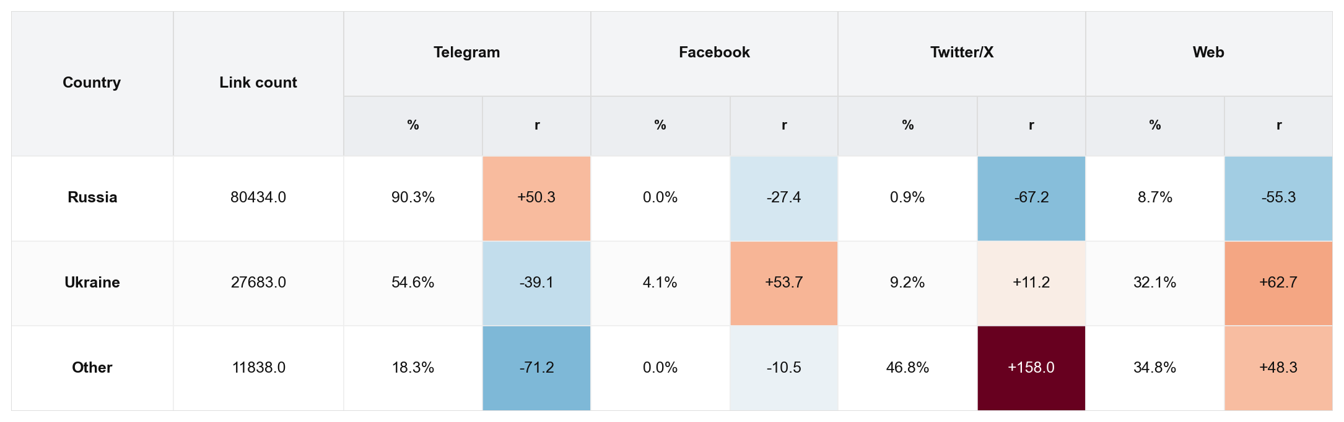
Table 3 Country vs. platform without Ukrainian General Staff Facebook page. The platform’s proportional share of the total number of links for each country (%) and the difference between observed and expected values measured in standardized residuals (r).
Importantly, this does not mean that Telegram is insignificant as a platform for Ukrainian sources in the ISW daily updates. Without the Facebook page of the general staff, Telegram accounts for 54.6% of all cited Ukrainian sources. But compared to Russian sources, Telegram plays a smaller role and there appears to be greater platform diversity when it comes to Ukraine. Most significantly, Facebook and the World Wide Web play a larger role.

H2: Type vs. country
We also find a clear overrepresentation of independent publishers among the sources cited by the ISW daily reports. More than 50% of the total number of references are to independent publishers across all platforms. This confirms hypothesis 2a.
If we look at the types of publishers by country, we see significant differences. As can be seen in Table 4, independent publishers are very significantly overrepresented for Russian sources (r=+88.8), whereas military institutions are even more significantly underrepresented (r=-116.0). For Ukraine, the exact opposite is true with independent publishers highly underrepresented (r=-111.6) and military institutions highly overrepresented (r=+172.2). The ISW also has a tendency to rely more on information from government institutions or individual politicians when the publishers are Ukrainian (r=+26.8 and r=+20.6) than when they are Russian (r=-22.2 and r=-7.3). This pattern holds even though the Telegram channel of the Russian Ministry of Defense is actually the third most cited source overall.
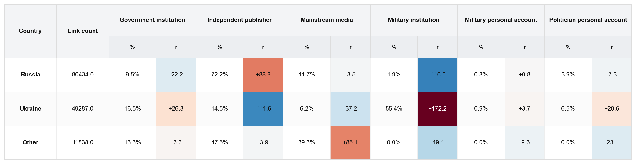
Table 4 Country vs. type. The type's proportional share of the total number of links for each country (%) and the difference between observed and expected values measured in standardized residuals (r).
Personal social media accounts from serving soldiers, including general staff-level officers, receive a limited number of references in both countries.
Overall, we find support for hypothesis 2b, as there is a significant difference in the types of sources ISW relies on for information from the different countries. The data suggests that there is greater trust in official sources from Ukraine than from Russia, where ISW tends to rely on independent publishers instead.

H3: Different sections and purposes
In total, 60.6% of all links in the political section before the key takeaways are to Telegram, whereas the same is true for 65.0% of the links in the military section after the key takeaways. However, as Table 5 and Table 6 show, there are significant geographical differences in what platforms ISW relies on in the different sections. For Russia, there is a heavy reliance on Telegram as a platform for information in the daily reports both before and after the key takeaways. Before the key takeaways, 80.2% of the links are to Telegram, whereas after the key takeaways, it is 94.3%. That is an overwhelming majority in both sections. The standardized residuals also show that ISW is more likely to rely on Telegram in both sections, but this over-representation of Telegram increases from +36.8 in the political section to +87.0 in the military section. This is a notable difference that indicates that ISW looks to Telegram for finding information about tactical movements on the frontline rather than other sources such as news websites.
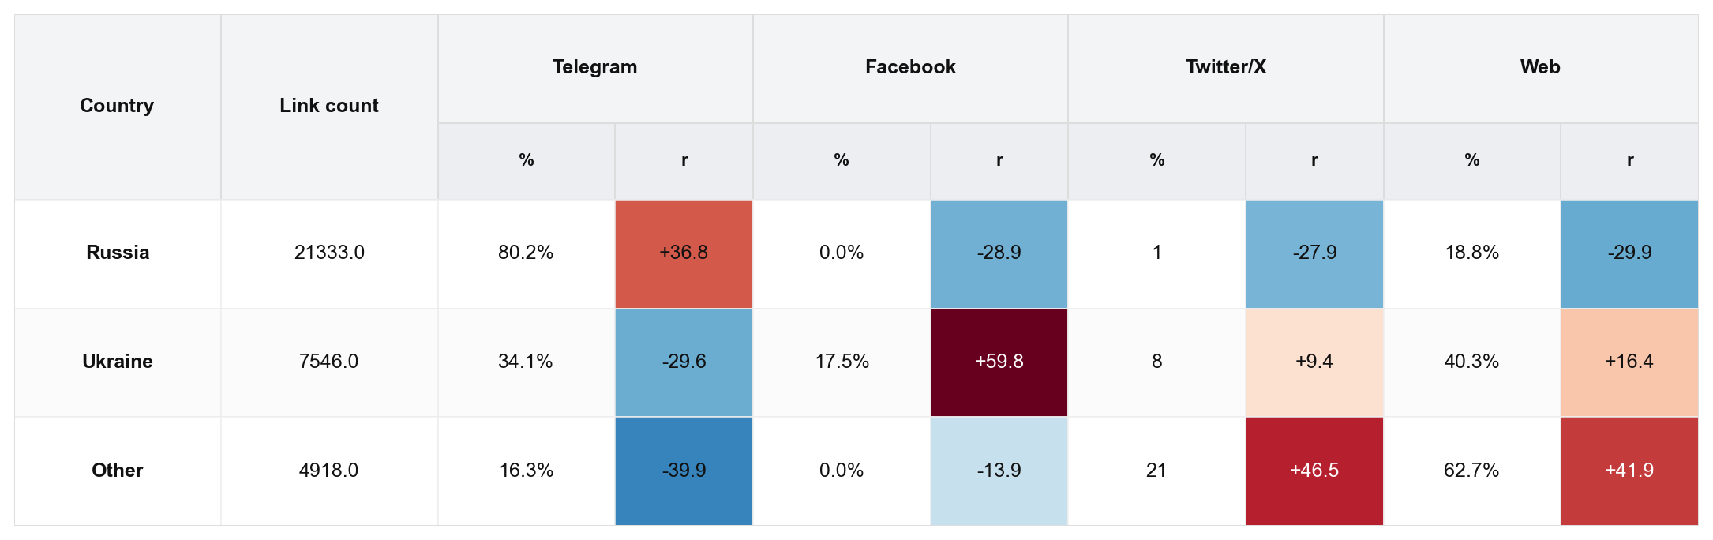
Table 5 Country vs. platform for political section. The platform's proportional share of the total number of links for each country (%) and the difference between observed and expected values measured in standardized residuals (r).

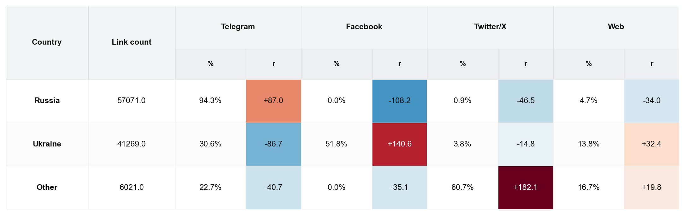
Table 6 Country vs. platform for military section. The platform's proportional share of the total number of links for each country (%) and the difference between observed and expected values measured in standardized residuals (r).
For Ukraine, the picture is more nuanced. In raw numbers, there is also with Ukrainian sources a high number of links to Telegram, which counts for 34.1% of the links in the political section and 30.6% of the links in the military. However, in the military section, Facebook is actually the biggest platform, accounting for 51.8% of the total number of links. Especially in the military section, the contrast to the profile of Russian links is stark. ISW relies heavily on Facebook (r=+140.6) and websites (r=+32.4), while Telegram is relatively underrepresented (r=-86.7).
For publishers from other countries than Ukraine and Russia, ISW is very inclined to find information on Twitter/X (r=+182.1) or to rely on webpages (r=+19.8).
When looking at the types of publisher in Table 7 and Table 8, there is a tendency toward the ISW relying more on independent publishers both before and after the key takeaways when it comes to Russian sources (r=+29.9 and r=+87.4). However, this is much more pronounced in the military section. This needs to be seen in relation with the finding above that ISW also tends to rely more on Telegram as a platform for Russian sources, and that this is also more pronounced in the military than the political section. In other words, ISW relies a lot on independent bloggers on Telegram when reporting the Russian perspective on military developments.
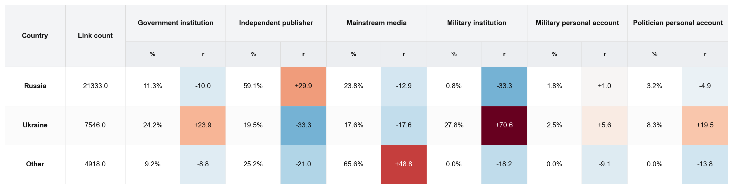
Table 7 Country vs. type in political section. The type's proportional share of the total number of links for each country (%) and the difference between observed and expected values measured in standardized residuals (r).
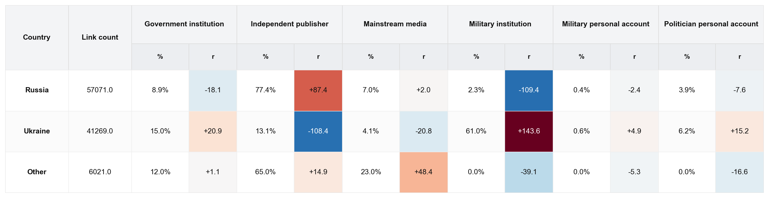
Table 8 Country vs. type in military section. The type's proportional share of the total number of links for each country (%) and the difference between observed and expected values measured in standardized residuals (r).
Conversely, there is a much greater tendency to rely on military institutions, government agencies, and statements from politicians for the Ukrainian perspective. Independent publishers are similarly underrepresented when it comes to Ukrainian sources, especially in the military section (r=-108.4). This indicates that ISW finds official sources from Ukraine more reliable than their Russian counterparts for accurate information that can be used for updated assessments of the battles on the frontline. It also suggests that the heavy use of information from independent Russian bloggers on Telegram is more a feature of a lack of trust in the Russian government than it is because ISW prefers independent voices in general. There are plenty of independent Ukrainian war reporters that they could have used if they wanted to.
For international sources, there is a stronger leaning toward mainstream media with r values of +48.8 in the political section and +48.4 in the military. This indicates that ISW relies quite a bit on international news media in their assessments. There is also a tendency for ISW to have a higher representation of links to independent publishers in the military section (r=+14.9). Held together with the also stronger reliance on Twitter/X as a platform, this indicates that ISW relies quite a bit on the international open-source community for reports on tactical military developments.

H4: Dealing with misinformation
Our final hypothesis (H4) was about Russian misinformation and whether ISW would treat Russian sources not as trustworthy sources, but as examples of misinformation to be refuted or political statements that need interpretation. A full assessment would require a qualitative reading of the text, which is beyond the scope of this paper. However, it is possible to gain an indication through a quantitative approach. Table 9 shows that there is indeed evidence suggesting that this may be at least partially the case.
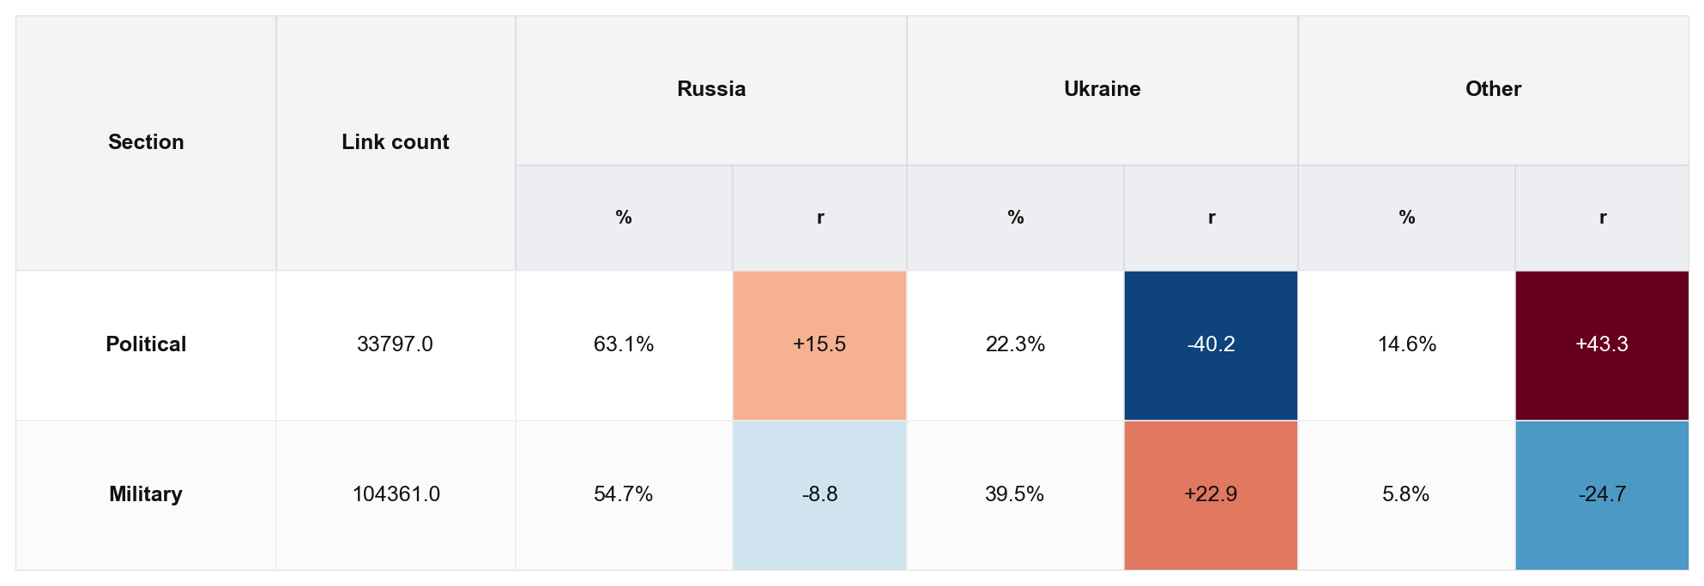
Table 9 Section vs. country. The country's proportional share of the total number of links for each section (%) and the difference between observed and expected values measured in standardized residuals (r).
ISW relies heavily on Russian sources in both the political and military parts of the updates, with more than half of the total number of links in both sections. However, statistically, Russian sources are overrepresented in the political sections, with an r value of +15.5. Conversely, Russian sources are underrepresented in the military section, with an r value of -8.8. This suggests that ISW relies less on Russian sources for tactical updates on the military situation. This type of reporting necessitates sources with access to military information from the frontlines, as well as credibility in their reporting, because accuracy is the highest priority.
The exact opposite pattern is visible when it comes to Ukrainian sources, with an r value of -40.2 in the political section and +22.9 in the military section.
The “Other” category displays a pattern similar to the Russian one, with an overrepresentation in the political section, showing an r value of +43.3, and an underrepresentation in the military category, reflecting an r value of -24.7. Held together with the finding above that international sources, particularly in the political section of the daily reports, tend to be mainstream media, this suggests that the political section could be largely a dialogue between Russian sources and reporting from international mainstream media.
This suggests that there might be an element of ISW referencing Russian sources in order to either dissect political statements or to debunk misinformation by comparing it to international media sources that are considered more trustworthy. This could explain why Russian sources are more referenced in the political section than in the military section where accuracy and credibility is more important. However, it's important to be aware that this is only an indication and that we have reached the limits of the explanatory power of the method presented in this paper. A qualitative reading of the texts is necessary to determine with greater accuracy whether this is indeed the reason for why Russian sources are overrepresented in the political sections of the daily updates.

Discussion
Our findings reveal that ISW relies on a broad range of sources for its daily updates. Overall, Telegram is by far the biggest platform, with 59% of all outgoing links. Especially for reporting the Russian perspective, Telegram plays a crucial role, with more than 90% of the total number of Russian links directing to the Telegram platform.
Telegram also plays a crucial role in reporting the Ukrainian perspective. It is not the largest platform for Ukrainian sources, but that is solely due to the fact that the single most cited publisher is the Facebook page of the Ukrainian General Staff. The Ukrainian General Staff is therefore a statistical outlier in the sense that this one channel elevates Facebook from being the smallest platform for Ukrainian links to being the largest. Indeed, the Ukrainian General Staff publishes status updates on both Facebook and Telegram. It might be more a reflection of the personal preferences of individual analysts at ISW whether they choose to link to the Facebook updates instead of the Telegram updates.
However, even if the Ukrainian general staff is excluded from the data set, it is clear that ISW relies on a much broader range of platforms to report the Ukrainian perspective, including a significantly higher usage of Facebook and Twitter/X compared to the Russian perspective. This must at least partly be explained by the fact that Facebook and Twitter have been banned in Russia since the spring of 2022.
The fact that the Ukrainian General Staff is the most cited source in the data set, with more than three times as many references as the second most cited source, is interesting in itself. It indicates that ISW has a high degree of trust in the Ukrainian authorities. This is also supported by our finding that ISW is much more likely to link to Ukrainian government institutions, military institutions, or politicians than to their Russian counterparts. Conversely, ISW relies heavily on independent publishers for the Russian perspective and has a strong preference for reporting that does not rely on official Russian sources, especially those from the military.
We also observe clear patterns in the sources that are cited for different sections of the daily updates. In the political section, before the key takeaways summary, ISW is most likely to cite Russian sources or sources from other countries than Ukraine. It is especially evident that ISW often references international mainstream media in the political section.
However, in the military section after the key takeaways, they tend to rely more on Ukrainian sources, with a strong preference for official military institutions, politicians, and government institutions. To the extent that a Russian source is cited in the military section, it is overwhelmingly likely to be a war blogger on Telegram. This indicates who ISW trusts to provide the most useful information in this part of the daily reports, where accuracy is the primary concern.
Overall, our findings do not support the notion that ISW would be reluctant to use Russian sources altogether due to concerns about trustworthiness or misinformation. Indeed, most of the sources are Russian. However, the study does indicate that ISW is more likely to use Ukrainian sources in those sections of the daily reports where they need precise and reliable information for updates on the tactical movements and the military situation.
On a more general level, our findings speak to the role that different types of military influencers play in shaping the public narrative about wars in a media ecology where smartphones and social media have been hugely disruptive. ISW has become an often-cited source for mainstream media reporting on the war. However, ISW is itself a significant consumer of open-source reporting by military influencers. ISW has thus taken on the role of curator of information — information which is mediated through the analytical work they perform and verified through trusted processes.
As mentioned in the introduction, some scholars emphasize how this changed media ecology has allowed independent bloggers and online influencers to replace traditional news sources and challenge the established power relationships between government agencies and news organizations (Ford and Hoskins 2022; Divon and Eriksson Krutrök 2025; Wall 2005). Others argue that despite the emergence of social media, we still see a mediascape dominated by traditional media and governments. By adopting some of the techniques and the language of social media influencers, they have managed to regain at least partial control of the public narrative (Hoskins and O’Loughlin 2015).
The findings in this study provide evidence to support both theses, which indicates that they are not necessarily mutually exclusive. We have found that ISW has a strong preference for using official government sources and mainstream media to analyze and report the Ukrainian perspective. However, when it comes to the Russian perspective, we observe the exact opposite phenomenon: they predominantly rely on independent publishers.
This indicates that government agencies and mainstream media still play a role in war reporting, but only insofar as they are considered trustworthy and useful. The moment they are not, independent publishers take over. It therefore opens perspectives on how military influencers and the open-source community on social media might indirectly shape the public narrative about wars by holding the government, military institutions, and mainstream media to higher standards regarding the provision of truthful and genuinely useful information rather than pushing politically convenient narratives. The moment trust in statements from the government is lost, the data suggests that the intended audience starts relying on alternative news sources instead.

Conclusion
In this article, we examine the references used by the Institute for the Study of War to produce its daily updates on the war in Ukraine, which have been frequently cited in Western media throughout the conflict. We find that ISW draws on a wide range of sources across different social-media platforms as well as traditional websites. By far the most prominent platform is Telegram, and most references are links to independent publishers.
However, we also find striking differences in the references ISW uses for different countries. While ISW relies heavily on war bloggers on Telegram for information from the Russian side of the frontline, it is much more likely to cite official government sources, politicians, or military institutions when reporting on Ukraine. Sources from other countries are most often international mainstream media outlets or open-source analysts on Twitter/X.
This suggests that Telegram, to some extent, has become a substitute for reliable news reporting from the Russian side, which creates a role for the military bloggers. However, this same dynamic also creates an important role for ISW itself. The greatest value of the daily updates, arguably, stems from the fact that ISW can make sense of the noise on Telegram and present it in a form accessible to Western mainstream media.
It also indicates that even in an era of social media and participatory warfare, military influencers occupy a distinct position within the media landscape. As long as government and military sources remain credible, and mainstream journalists can meet basic professional standards, ISW tends to prefer those sources. But when they fail to do so, military bloggers on social media are ready to fill the gap.
In that sense, the very existence of independent military influencers helps maintain pressure on governments and traditional media to uphold high standards of credibility by offering an alternative narrative. To retain influence, official and mainstream actors must provide information that is perceived as useful and accurate—otherwise, they will be outcompeted by social-media influencers.

Funding
No external funding was received for this project.

References
Bareikytė, Miglė, and Mykola Makhortykh. 2024. “Digitally Witnessable War from Pereklychka to Propaganda: Unfolding Telegram Communication during Russia’s War in Ukraine.” Media, War & Conflict, July 26, 17506352241255890. https://doi.org/10.1177/17506352241255890.
Bareikytė, Miglė, Mykola Makhortykh, Alexander Martin, Taras Nazaruk, and Yarden Skop. 2024. “How Should Platforms Be Archived? On Sustainable Use Practices of a Telegram Archive to Study Russia’s War against Ukraine.” Media, Culture & Society 46 (7): 1378–96. https://doi.org/10.1177/01634437241245915.
Bösch, Marcus, and Tom Divon. 2024. “The Sound of Disinformation: TikTok, Computational Propaganda, and the Invasion of Ukraine.” New Media & Society 26 (9): 5081–106. https://doi.org/10.1177/14614448241251804.
Bowd, Kathryn. 2016. “Social Media and News Media: Building New Publics or Fragmenting Audiences?” In Making Publics, Making Places, by Mary Griffiths and Kim Barbour. University of Adelaide Press. https://doi.org/10.20851/publics-08.
Canevez, Richard Noel, Kateryna Maikovska, and Lara Zwarun. 2024. “Tactics and Affordances in the Mediatization of War: Pro-Ukrainian Cyber Resistance on Telegram.” Digital War 5 (3): 167–80. https://doi.org/10.1057/s42984-024-00096-x.
Divon, Tom, and Moa Eriksson Krutrök. 2025. “The Rise of War Influencers: Creators, Platforms, and the Visibility of Conflict Zones.” Platforms & Society 2 (March): 29768624251325721. https://doi.org/10.1177/29768624251325721.
Ford, Matthew, and Andrew Hoskins. 2022. Radical War: Data, Attention and Control in the Twenty-First Century. Hurst & Company.
Gill, Matthew J. 2017. “Chi-Square.” In The SAGE Encyclopedia of Communication Research Methods, by Mike Allen. SAGE Publications, Inc. https://doi.org/10.4135/9781483381411.n55.
Hoskins, Andrew, and Ben O’Loughlin. 2015. “Arrested War: The Third Phase of Mediatization.” Information, Communication & Society 18 (11): 1320–38. https://doi.org/10.1080/1369118X.2015.1068350.
Hoskins, Andrew, and Pavel Shchelin. 2023. “The War Feed: Digital War in Plain Sight.” American Behavioral Scientist 67 (3): 449–63. https://doi.org/10.1177/00027642221144848.
Kallioniemi, Pekka. 2021. “The Role of Human Curation at the Age of Algorithms.” Journal of Digital Media & Interaction 4 n.º 10 (July): 7-20 Páginas. 7-20 Páginas. https://doi.org/10.34624/JDMI.V4I10.24529.
Kalnes, Øyvind, and Nina M. Bjørge. 2025. “‘So, We Have Occupied TikTok’: Ukrainian Women in #ParticipativeWar.” Media, War & Conflict 18 (2): 233–50. https://doi.org/10.1177/17506352241307010.
Lai, Cameron, Fujio Toriumi, and Mitsuo Yoshida. 2024. “A Multilingual Analysis of pro Russian Misinformation on Twitter during the Russian Invasion of Ukraine.” Scientific Reports 14 (1): 10155. https://doi.org/10.1038/s41598-024-60653-y.
Lokot, Tetyana. 2023. “The Role of Citizens’ Affective Media Practices in Participatory Warfare during Russia’s Invasion of Ukraine.” Journal of International Relations and Development 26 (4): 776–90. https://doi.org/10.1057/s41268-023-00317-y.
McHugh, Mary L. 2013. “The Chi-Square Test of Independence.” Biochemia Medica, 143–49. https://doi.org/10.11613/BM.2013.018.
Merrin, William. 2019. Digital War: A Critical Introduction. Routledge Taylor & Francis Group.
Merrin, William, and Andrew Hoskins. 2020. “Tweet Fast and Kill Things: Digital War.” Digital War 1 (1–3): 184–93. https://doi.org/10.1057/s42984-020-00002-1.
Milmo, Dan. 2022. “Russia Blocks Access to Facebook and Twitter.” World News. The Guardian, March 4. https://www.theguardian.com/world/2022/mar/04/russia-completely-blocks-access-to-facebook-and-twitter.
Norman, Jethro, Matthew Ford, and Signe Marie Cold-Ravnkilde. 2024. “The Crisis in the Palm of Our Hand.” International Affairs 100 (4): 1361–79. https://doi.org/10.1093/ia/iiae128.
Oleinik, Anton, and Volodymyr Paniotto. 2024. “Propaganda Channels and Their Comparative Effectiveness: The Case of Russia’s War in Ukraine.” International Sociology 39 (3): 217–40. https://doi.org/10.1177/02685809241232637.
Özdemir, Hüseyin. 2023. “The Rise of Military Bloggers Amid the Russian-Ukrainian War.” TRT World Research Centre, January. https://researchcentre.trtworld.com/wp-content/uploads/2023/02/Miltary-Bloggers_V2.pdf.
Ptaszek, Grzegorz, Bohdan Yuskiv, and Sergii Khomych. 2024. “War on Frames: Text Mining of Conflict in Russian and Ukrainian News Agency Coverage on Telegram during the Russian Invasion of Ukraine in 2022.” Media, War & Conflict 17 (1): 41–61. https://doi.org/10.1177/17506352231166327.
Santos Okholm, Christiern. 2025. “Adapting Nord Stream 2: How Russia Adapts Strategic Narratives to English-Speaking Polish and German Audiences.” Media, War & Conflict 18 (1): 63–81. https://doi.org/10.1177/17506352241243301.
Schrijver, Peter. 2025. “Ukrainian Intelligence’s Use of Telegram in Wartime.” International Journal of Intelligence and CounterIntelligence, July 8, 1–27. https://doi.org/10.1080/08850607.2025.2522222.
Statista. 2025. “Russia: Most Used Social Media Platforms 2024.” https://www.statista.com/statistics/867549/top-active-social-media-platforms-in-russia/?srsltid=AfmBOorrohJBm-CHw033i82djZ92vOlaRoAJuv_UUNuaLIwt-7Oz-LWY.
Wall, Melissa. 2005. “‘Blogs of War’: Weblogs as News.” Journalism 6 (2): 153–72. https://doi.org/10.1177/1464884905051006.
Wasike, Ben. 2025. “Influencing the News: How Social Media Influencers Affect News Media Trust.” Information, Communication & Society, April 25, 1–18. https://doi.org/10.1080/1369118X.2025.2496907.

List of figures and tables

Figures
Figure 1 Daily distribution of sources from different media platforms as a percentage of all sources cited in the daily update. All sources (left) vs. unique sources (right).

Tables
Table 1 Filtering by influence. Publishers cited more than 50 times in the ISW daily updates are retained.
Table 2 Country vs. platform. The platform's proportional share of the total number of links for each country (%) and the difference between observed and expected values measured in standardized residuals (r).
Table 3 Country vs. platform without Ukrainian General Staff Facebook page. The platform’s proportional share of the total number of links for each country (%) and the difference between observed and expected values measured in standardized residuals (r).
Table 4 Country vs. type. The type's proportional share of the total number of links for each country (%) and the difference between observed and expected values measured in standardized residuals (r).
Table 5 Country vs. platform for political section. The platform's proportional share of the total number of links for each country (%) and the difference between observed and expected values measured in standardized residuals (r).
Table 6 Country vs. platform for military section. The platform's proportional share of the total number of links for each country (%) and the difference between observed and expected values measured in standardized residuals (r).
Table 7 Country vs. type in political section. The type's proportional share of the total number of links for each country (%) and the difference between observed and expected values measured in standardized residuals (r).
Table 8 Country vs. type in military section. The type's proportional share of the total number of links for each country (%) and the difference between observed and expected values measured in standardized residuals (r).
Table 9 Section vs. country. The country's proportional share of the total number of links for each section (%) and the difference between observed and expected values measured in standardized residuals (r).

Appendix 1: List of influential publishers
Rank | Platform | Publisher name | Link count | Country | Type | Comments
1 | Facebook | generalstaff.ua | 21604 | Ukraine | Military institution | Ukrainian General Staff
2 | Telegram | rybar | 6155 | Russia | Independent publisher | Russian war blog
3 | Telegram | mod_russia | 5448 | Russia | Government institution | Russian Ministry of Defense
4 | Telegram | dva_majors | 5334 | Russia | Independent publisher | Russian war blog
5 | Telegram | wargonzo | 5070 | Russia | Independent publisher | Russian war blog
6 | Telegram | boris_rozhin | 4284 | Russia | Independent publisher | Boris Rozhin, Russian war blog
7 | Telegram | RVvoenkor | 3976 | Russia | Independent publisher | Russian war blog
8 | Telegram | DnevnikDesantnika | 3848 | Russia | Independent publisher | Russian war blog
9 | Web | armyinform.com.ua | 3794 | Ukraine | Government institution
10 | Telegram | tass_agency | 3369 | Russia | Mainstream media | TASS, Russian news agency
11 | Telegram | voenkorKotenok | 3045 | Russia | Independent publisher | Yury Kotenok, Russian war correspondent
12 | Web | suspilne.media | 2696 | Ukraine | Mainstream media
13 | Telegram | readovkanews | 1989 | Russia | Independent publisher | Russian war blog
14 | Web | tass.ru | 1821 | Russia | Mainstream media
15 | Telegram | GeneralStaffZSU | 1684 | Ukraine | Military institution | Ukrainian General Staff
16 | Telegram | creamy_caprice | 1495 | Russia | Independent publisher | Russian war blog
17 | Telegram | z_arhiv | 1348 | Russia | Independent publisher | Russian war blog
18 | Telegram | voin_dv | 1316 | Russia | Independent publisher | Russian war blog
19 | Telegram | milinfolive | 1262 | Russia | Independent publisher | Russian war blog
20 | Telegram | zvizdecmanhustu | 1232 | Ukraine | Independent publisher | Konstiantyn Mashovets, Ukrainian military analyst
21 | Web | meduza.io | 1222 | Russia | Mainstream media
22 | Telegram | motopatriot | 1196 | Russia | Independent publisher | Russian war blog
23 | Telegram | rusich_army | 1132 | Russia | Independent publisher | Russian war blog
24 | Web | kremlin.ru | 1050 | Russia | Government institution
25 | Telegram | sashakots | 980 | Russia | Independent publisher | Aleksandr Kots, Russian war correspondent
26 | Telegram | Khortytsky_wind | 978 | Ukraine | Military institution | Khortytsia Operational-Strategic Group
27 | Telegram | astrapress | 887 | Russia | Independent publisher | Russian opposition media
28 | Telegram | vrogov | 877 | Russia | Politician personal account | Pro-Russian Ukrainian politician/collaborator
29 | Web | sprotyv.mod.gov.ua | 869 | Ukraine | Government institution | Center of National Resistance of Ukraine
30 | Twitter/X | 666_mancer | 850 | Ukraine | Independent publisher | OSINT channel
31 | Twitter/X | girkingirkin | 757 | Russia | Independent publisher | Igor Girkin
32 | Telegram | NeoficialniyBeZsonoV | 725 | Russia | Independent publisher | Russian war blog
33 | Web | reuters.com | 698 | Other | Mainstream media
34 | Telegram | vysokygovorit | 696 | Russia | Independent publisher | Russian war blog
35 | Telegram | yurasumy | 691 | Russia | Independent publisher | Russian war blog
36 | Telegram | luhanskaVTSA | 679 | Ukraine | Government institution | Luhansk Oblast Military-Civil Administration
37 | Telegram | epoddubny | 675 | Russia | Independent publisher | Russian war blog
38 | Telegram | stranaua | 668 | Ukraine | Independent publisher | Pro-Russian Ukrainian media outlet
39 | Web | ria.ru | 660 | Russia | Mainstream media
40 | Telegram | modmilby | 654 | Other | Government institution | Ministry of Defense of Belarus
41 | Twitter/X | geoconfirmed | 654 | Other | Independent publisher | OSINT channel
42 | Telegram | kpszsu | 649 | Ukraine | Military institution | Ukrainian Air Force
43 | Telegram | synegubov | 625 | Ukraine | Politician personal account | Oleh Syniehubov, Governor of Kharkiv Oblast State/Military Administration
44 | Telegram | motopatriot78 | 624 | Russia | Independent publisher | Russian war blog
45 | Telegram | grey_zone | 616 | Russia | Independent publisher | Unofficial Wagner channel
46 | Telegram | hueviyherson | 574 | Ukraine | Independent publisher | City news from Kherson
47 | Telegram | notes_veterans | 574 | Russia | Independent publisher | Russian war blog
48 | Telegram | nm_dnr | 548 | Russia | Military institution | People’s Militia of DPR
49 | Twitter/X | moklasen | 541 | Other | Independent publisher | OSINT channel
50 | Telegram | Sladkov_plus | 540 | Russia | Independent publisher | Russian war correspondent Alexander Sladkov
51 | Telegram | zoda_gov_ua | 534 | Ukraine | Government institution | Zaporizhzhia Oblast Military Administration
52 | Telegram | WarArchive_ua | 533 | Ukraine | Independent publisher | Ukrainian war blog
53 | Telegram | kommunist | 532 | Russia | Independent publisher | Russian war blog
54 | Web | rbc.ru | 532 | Russia | Mainstream media
55 | Web | gur.gov.ua | 532 | Ukraine | Military institution
56 | Telegram | vchkogpu | 517 | Russia | Independent publisher | Removed from Telegram after request from Russia. See ISW 2025-04-07.
57 | Telegram | MID_Russia | 508 | Russia | Government institution | Russian Ministry of Foreign Affairs
58 | Telegram | bbcrussian | 507 | Other | Mainstream media | BBC Russian service
59 | Telegram | negumanitarnaya_pomosch_Z | 507 | Russia | Independent publisher | Russian war blog
60 | Telegram | andriyshTime | 500 | Ukraine | Independent publisher | Ukrainian war blog with news from the occupied areas
61 | Telegram | strelkovii | 488 | Russia | Independent publisher | Russian war blog, Igor Girkin
62 | Telegram | concordgroup_official | 471 | Russia | Military personal account | Prigozhin’s press service
63 | Telegram | RKadyrov_95 | 470 | Russia | Politician personal account | Ramzan Kadyrov
64 | Telegram | SJTF_Odes | 466 | Ukraine | Military institution | Southern Joint Task Force (SJTF) of Ukraine’s Defense Forces
65 | Twitter/X | bayraktar_1love | 459 | Ukraine | Independent publisher | Special Kherson Cat
66 | Telegram | sotaproject | 450 | Russia | Independent publisher | Russian opposition media
67 | Telegram | dnipropetrovskaODA | 419 | Ukraine | Government institution | Dnipropetrovsk Oblast State (Military) Administration
68 | Telegram | bazabazon | 417 | Russia | Independent publisher | Russian war blog
69 | Twitter/X | ralee85 | 410 | Other | Independent publisher | Rob Lee, military analyst
70 | Twitter/X | defencehq | 395 | Other | Government institution | UK Ministry of Defence
71 | Telegram | mobilizationnews | 383 | Russia | Independent publisher | Russian activism regarding soldiers’ rights
72 | Twitter/X | ejshahid | 372 | Ukraine | Independent publisher | OSINT channel
73 | Telegram | NgP_raZVedka | 368 | Russia | Independent publisher | Russian war blog
74 | Telegram | russkiy_opolchenec | 339 | Russia | Military institution | Russian Legion (BARS-13)
75 | Twitter/X | audaxonx | 337 | Ukraine | Independent publisher | OSINT channel
76 | Telegram | m0sc0wcalling | 335 | Russia | Independent publisher | Russan war blog
77 | Telegram | prigozhin_2023_tg | 327 | Russia | Independent publisher | Russian war blog, unofficial Wagner channel
78 | Telegram | Bratchuk_Sergey | 326 | Ukraine | Politician personal account | Serhiy Bratchuk, former spokesman for the Odesa regional/military administration
79 | Web | president.gov.ua | 326 | Ukraine | Government institution
80 | Web | kommersant.ru | 326 | Russia | Mainstream media
81 | Web | nytimes.com | 321 | Other | Mainstream media
82 | Facebook | operationalcommandsouth | 317 | Ukraine | Military institution | Operational Command “South”
83 | Telegram | VGA_Kherson | 315 | Russia | Government institution | Russian Administration in Kherson
84 | Telegram | batalyon15 | 309 | Russia | Military institution | 166th Motorized Rifle Regiment
85 | Telegram | basurin_e | 306 | Russia | Independent publisher | Russian war blog
86 | Telegram | miroshnik_r | 304 | Russia | Politician personal account | Rodion Miroshnik, LNR politician
87 | Web | interfax.ru | 302 | Russia | Mainstream media
88 | Telegram | annamaliar | 301 | Ukraine | Politician personal account | Hanna Maliar, former deputy defense minister of Ukraine
89 | Telegram | SALDO_VGA | 297 | Russia | Politician personal account | Vladimir Saldo, Russian-installed head of Kherson Oblast
90 | Telegram | ivan_fedorov_melitopol | 292 | Ukraine | Politician personal account | Ivan Federov, formerly elected mayor of Melitopol. Old channel – now ivan_fedorov_zp
91 | Telegram | istories_media | 275 | Russia | Independent publisher | Russian opposition media
92 | Web | cnn.com | 275 | Other | Mainstream media
93 | Web | bbc.com | 272 | Other | Mainstream media
94 | Telegram | mykolaivskaODA | 261 | Ukraine | Government institution | Mykolaiv Oblast Military Administration
95 | Facebook | okpivden | 259 | Ukraine | Military institution | Old name for Operational Command “South”
96 | Telegram | milchronicles | 256 | Russia | Independent publisher | Russian war blog
97 | Telegram | spravdi | 255 | Ukraine | Government institution | Centre for Strategic Communications and Information Security
98 | Telegram | philologist_zov | 253 | Russia | Independent publisher | Russian war blog
99 | Telegram | severrealii | 253 | Other | Mainstream media | RFE/RL
100 | Telegram | V_Zelenskiy_official | 252 | Ukraine | Politician personal account | Volodymir Zelenskyy
101 | Telegram | khersonskaODA | 250 | Ukraine | Government institution | Kherson Oblast Military Administration
102 | Telegram | vladlentatarsky | 248 | Russia | Independent publisher | Russian war blog
103 | Facebook | sergey.khlan | 247 | Ukraine | Politician personal account | Sergey Khlan
104 | Web | washingtonpost.com | 247 | Other | Mainstream media
105 | Twitter/X | tatarigami_ua | 243 | Ukraine | Independent publisher | Tatarigami, Military analyst
106 | Telegram | ButusovPlus | 241 | Ukraine | Independent publisher | Ukrainian war blog
107 | Web | bloomberg.com | 241 | Other | Mainstream media
108 | Twitter/X | neonhandrail | 239 | Other | Independent publisher | OSINT channel
109 | Twitter/X | militarylandnet | 238 | Other | Independent publisher | OSINT channel
110 | Twitter/X | blinzka | 236 | Other | Independent publisher | OSINT channel
111 | Telegram | rian_ru | 229 | Russia | Mainstream media | Ria Novosti
112 | Twitter/X | gik1893 | 224 | Other | Independent publisher | OSINT channel
113 | Telegram | DIUkraine | 222 | Ukraine | Military institution | Main Intelligence Directorate (HUR) of Ukraine’s Ministry of Defense
114 | Telegram | otukharkiv | 222 | Ukraine | Military institution | Operational Tactical Group “Kharkiv”
115 | Web | notes.citeam.org | 212 | Russia | Independent publisher
116 | Web | iz.ru | 209 | Russia | Mainstream media
117 | Telegram | multi_XAM | 204 | Russia | Independent publisher | Pro-Russian OSINT channel
118 | Telegram | pushilindenis | 202 | Russia | Politician personal account | Denis Pushilin, head of Donetsk People’s Republic (DPR)
119 | Twitter/X | auditor_ya | 200 | Other | Independent publisher | OSINT channel
120 | Telegram | Yevtushenko_E | 198 | Ukraine | Politician personal account | Yevhen Yevtushenko, head of the Nikopol District Military Administration
121 | Twitter/X | klinger66 | 198 | Other | Independent publisher | OSINT channel
122 | Web | pravda.com.ua | 197 | Ukraine | Mainstream media
123 | Web | ft.com | 195 | Other | Mainstream media
124 | Telegram | osirskiy | 194 | Ukraine | Military personal account | Oleksandr Syrskyi, chief of defense, Ukraine
125 | Telegram | svobodnieslova | 192 | Russia | Mainstream media | Russian opposition channel Verstka Media
126 | Telegram | swodki | 191 | Russia | Independent publisher | Pro-Russian military-oriented news outlet
127 | Telegram | romanov_92 | 187 | Russia | Independent publisher | Romanov Лайт, pro-russian mil-blogger
128 | Web | ukrinform.ua | 187 | Ukraine | Mainstream media
129 | Telegram | glava_lnr_info | 185 | Russia | Politician personal account | Leonid Pasechnik, head of Luhansk People’s Republic (LPR)
130 | Telegram | BalitskyEV | 184 | Russia | Politician personal account | Yevhen Balitsky, head of the administration in occupied Zaporizhzhia Oblast
131 | Telegram | belta_telegramm | 181 | Other | Mainstream media | Belarusian state news agency
132 | Web | wsj.com | 181 | Other | Mainstream media
133 | Web | mil.in.ua | 179 | Ukraine | Independent publisher
134 | Telegram | pul_1 | 178 | Other | Independent publisher | Officially independent Belarusian pro-government channel
135 | Web | belta.by | 178 | Other | Mainstream media | Belarus news agency
136 | Telegram | vilkul | 177 | Ukraine | Politician personal account | Oleksandr Yuriyovych Vilkul, Head of the Military Administration of Kryvyi Rih
137 | Web | mid.ru | 176 | Russia | Government institution
138 | Telegram | sons_fatherland | 174 | Russia | Independent publisher | Russian war blog
139 | Telegram | aleksandr_skif | 173 | Russia | Military personal account | Aleksandr Khodakovsky, deputy head of Rosgvardya in DPR
140 | Telegram | brussinf | 173 | Russia | Independent publisher | Russian war correspondent Alexander Simonov
141 | Telegram | idelrealii | 173 | Other | Mainstream media | Operated by Radio Free Europe/Radio Liberty (RFE/RL)
142 | Telegram | kiber_boroshno | 173 | Ukraine | Independent publisher | Ukrainian OSINT channel
143 | Twitter/X | danspiun | 173 | Other | Independent publisher | OSINT channel
144 | Web | vedomosti.ru | 170 | Russia | Mainstream media
145 | Web | apnews.com | 165 | Other | Mainstream media
146 | Telegram | rusbrief | 155 | Russia | Independent publisher | Independent pro-Russian channel shut down by the Kremlin after being labeled a foreign agent
147 | Telegram | belarusian_silovik | 149 | Other | Independent publisher | Pro-Russian state affiliated channel
148 | Telegram | energoatom_ua | 147 | Ukraine | Government institution | Energoatom
149 | Telegram | Prigozhin_hat | 143 | Russia | Independent publisher | Wagner related channel
150 | Web | rferl.org | 139 | Other | Mainstream media
151 | Telegram | ComAFUA | 138 | Ukraine | Military institution | Ukrainian air force command
152 | Telegram | TRO_DPR | 138 | Russia | Military institution | Defense staff of DPR
153 | Telegram | pavlokyrylenko_donoda | 137 | Ukraine | Politician personal account | Pavlo Kyrylenko, head of Ukrainian Donetsk Regional Military Administration
154 | Telegram | rlz_the_kraken | 135 | Russia | Independent publisher | Pro-Russian milblogger
155 | Twitter/X | bielitzling | 134 | Other | Independent publisher | OSINT channel
156 | Web | defense.gov | 134 | Other | Government institution
157 | Web | theguardian.com | 133 | Other | Mainstream media
158 | Telegram | RtrDonetsk | 125 | Russia | Independent publisher | Andrey Rudenko, Russian war correspondent
159 | Telegram | Aksenov82 | 122 | Russia | Politician personal account | Sergey Aksyonov, Russia-installed head of “Republic of Crimea”
160 | Telegram | razvozhaev | 122 | Russia | Politician personal account | Mikhail Razvozhayev, Russian-appointed governor of Sevastopol
161 | Telegram | voenacher | 122 | Russia | Independent publisher | Povyornutye na voyne, Russian mil-blogger channel
162 | Telegram | mykola_lukashuk | 119 | Ukraine | Politician personal account | Mykola Lukashuk, Chairman of the Dnipropetrovsk Oblast Council
163 | Twitter/X | germanobserver1 | 119 | Other | Independent publisher | OSINT channel
164 | Twitter/X | 99dominik_ | 118 | Other | Independent publisher | OSINT channel
165 | Telegram | batalyon_vostok | 116 | Russia | Military institution | Russian 114th Guards Motor Rifle Brigade
166 | Telegram | warhistoryalconafter | 116 | Russia | Independent publisher | Pro-Russian mil-blogger
167 | Telegram | vdv_ZA_teplinsky | 114 | Russia | Independent publisher | Russian mil-blogger, support page for general Teplinsky
168 | Telegram | ivan_fedorov_zp | 113 | Ukraine | Politician personal account | Ivan Fedorov, Head of the Zaporizhzhia Regional Military Administration
169 | Telegram | MedvedevVesti | 112 | Russia | Politician personal account | Andrey Medvedev, pro-Kremlin journalist and politician
170 | Facebook | pashtetof | 112 | Ukraine | Independent publisher | Konstyantyn Mashovets, military analyst
171 | Telegram | rsotmdivision | 111 | Russia | Independent publisher | Pro-Russian mil-blogger
172 | Facebook | presscentrtavria | 111 | Ukraine | Military institution | Press service of the Tavria grouping of forces
173 | Twitter/X | noelreports | 107 | Other | Independent publisher | OSINT channel
174 | Twitter/X | pauljawin | 107 | Other | Independent publisher | OSINT channel
175 | Web | state.gov | 107 | Other | Government institution
176 | Telegram | ihor_terekhov | 106 | Ukraine | Politician personal account | Ihor Terekhov, mayor of Kharkiv
177 | Telegram | odeskaODA | 106 | Ukraine | Government institution | Odesa Regional Military/State Administration
178 | Twitter/X | vigorousfalcon | 106 | Other | Independent publisher | OSINT channel
179 | Web | publication.pravo.gov.ru | 105 | Ukraine | Government institution
180 | Web | iaea.org | 102 | Other | Government institution
181 | Telegram | millnr | 99 | Russia | Military institution | People’s Militia of the Luhansk People’s Republic
182 | Telegram | otarnavskiy | 98 | Ukraine | Military personal account | Brig. Gen. Oleksandr Tarnavskyi
183 | Web | lenta.ru | 98 | Russia | Mainstream media
184 | Web | verstka.media | 96 | Russia | Mainstream media
185 | Twitter/X | wartranslated | 95 | Other | Independent publisher | OSINT channel
186 | Telegram | Alekhin_Telega | 92 | Russia | Independent publisher | Roman Alekhin, pro-Russian war commentator
187 | Telegram | mariupolnow | 90 | Ukraine | Independent publisher | News from Mariupol
188 | Twitter/X | blue_sauron | 89 | Other | Independent publisher | OSINT channel
189 | Twitter/X | markito0171 | 89 | Other | Independent publisher | OSINT channel
190 | Telegram | VA_Kyiv | 88 | Ukraine | Government institution | Kyiv city military administration
191 | Telegram | der_rada | 88 | Ukraine | Government institution | Derhachi City Council
192 | Twitter/X | intelcrab | 88 | Other | Independent publisher | OSINT channel
193 | Twitter/X | mikivalbuena | 87 | Other | Independent publisher | OSINT channel
194 | Telegram | akovalenko1989 | 86 | Ukraine | Military personal account | Andrii Kovalenko, Head of the Center for Countering Disinformation
195 | Telegram | ostorozhno_novosti | 86 | Russia | Independent publisher | Ostorozhno Novosti, Russian news channel
196 | Telegram | serhiy_hayday | 85 | Ukraine | Politician personal account | Serhiy Haidai, former head of Ukraine’s Luhansk Regional Military Administration
197 | Web | gazeta.ru | 85 | Russia | Mainstream media
198 | Telegram | Stremousov_Kirill | 82 | Russia | Politician personal account | Kirill Stremousov, deputy head of the occupation Kherson military-civilian administration
199 | Telegram | arbat | 82 | Russia | Independent publisher | Russian political and military commentary
200 | Telegram | malvovabelova | 81 | Russia | Politician personal account | Maria Lvova-Belova, Presidential Commissioner for Children’s Rights
201 | Telegram | medvedev_telegram | 81 | Russia | Politician personal account | Dmitry Medvedev, former president of Russia
202 | Telegram | operativnoZSU | 78 | Ukraine | Independent publisher | Operational AFU, pro-Ukrainian war news/OSINT aggregator
203 | Twitter/X | pauliuszaleckas | 78 | Other | Independent publisher | OSINT channel
204 | Telegram | sledcom_press | 77 | Russia | Government institution | Russia’s Investigative Committee
205 | Facebook | defenceintelligenceofukraine | 77 | Ukraine | Military institution | Ukrainian Military Intelligence (HUR)
206 | Twitter/X | osintua | 77 | Ukraine | Military personal account | Ukrainian soldier
207 | Web | whitehouse.gov | 77 | Other | Government institution
208 | Telegram | Hajun_BY | 76 | Other | Independent publisher | Belarusian opposition OSINT group
209 | Telegram | dsns_telegram | 76 | Ukraine | Government institution | State Emergency Service of Ukraine
210 | Telegram | kremlin_sekret | 76 | Russia | Independent publisher | Kremlin Whispers, rumors and analysis about Russian politics
211 | Twitter/X | zelenskyyua | 76 | Ukraine | Politician personal account | Volodymyr Zelenskyy
212 | Telegram | smotri_z | 74 | Russia | Independent publisher | Russian pro-war news feed
213 | Twitter/X | serder_daniels | 74 | Other | Independent publisher | OSINT channel
214 | Twitter/X | cosmonaut19 | 73 | Other | Independent publisher | OSINT channel
215 | Telegram | orlovdmytroEn | 72 | Ukraine | Politician personal account | Dmytro Orlov, mayor of Enerhodar
216 | Twitter/X | small10space | 72 | Ukraine | Independent publisher | OSINT channel
217 | Twitter/X | bradyafr | 71 | Other | Independent publisher | OSINT channel
218 | Web | politico.eu | 71 | Other | Mainstream media
219 | Telegram | Mestb_Dobroj_Voli | 70 | Russia | Independent publisher | Russian mil-blogger
220 | Telegram | ssternenko | 69 | Ukraine | Independent publisher | Serhii Sternenko, Ukrainian activist
221 | Twitter/X | tuiteromartin | 68 | Other | Independent publisher | OSINT channel
222 | Web | criticalthreats.org | 68 | Other | Independent publisher
223 | Telegram | DeepStateUA | 67 | Ukraine | Independent publisher | Ukrainian OSINT channel
224 | Telegram | akashevarova | 67 | Russia | Independent publisher | Russian war blog
225 | Twitter/X | defmon3 | 66 | Other | Independent publisher | OSINT channel
226 | Telegram | horizontal_russia | 65 | Russia | Independent publisher | Russian regional news
227 | Twitter/X | gloooud | 65 | Ukraine | Independent publisher | OSINT channel
228 | Twitter/X | osinttechnical | 65 | Other | Independent publisher | OSINT channel
229 | Twitter/X | puenteuribarri | 65 | Other | Independent publisher | OSINT channel
230 | Telegram | Sumy_news_ODA | 64 | Ukraine | Government institution | Sumy Regional Military/State Administration
231 | Twitter/X | jackdetsch | 64 | Other | Independent publisher | US journalist
232 | Web | radiosvoboda.org | 64 | Other | Mainstream media
233 | Telegram | btr80 | 63 | Russia | Independent publisher | Russian mil-blogger
234 | Telegram | militarymediacenter | 63 | Ukraine | Independent publisher | Bot-like mirror of official Ukrainian military information
235 | Web | economist.com | 63 | Other | Mainstream media
236 | Telegram | ZA_FROHT | 62 | Russia | Independent publisher | Russian war blog
237 | Telegram | KRPRus | 61 | Russia | Independent publisher | Russian war blog
238 | Telegram | SolovievLive | 61 | Russia | Mainstream media | Vladimir Solovyov, pro-Kremlin propaganda
239 | Web | telegraph.co.uk | 61 | Other | Mainstream media
240 | Web | forbes.com | 60 | Other | Mainstream media
241 | Web | mil.ru | 60 | Russia | Government institution
242 | Telegram | osetin20 | 59 | Russia | Independent publisher | Russian war blog
243 | Telegram | AFUStratCom | 58 | Ukraine | Military institution | Information office of the Ukrainian Armed Forces
244 | Telegram | wehearfromyanina | 58 | Russia | Independent publisher | Russian war blog
245 | Twitter/X | fdov21 | 58 | Other | Independent publisher | OSINT channel
246 | Twitter/X | hajun_by | 57 | Other | Independent publisher | Belarusian Hajun project
247 | Web | politico.com | 57 | Other | Mainstream media
248 | Web | nbcnews.com | 57 | Other | Mainstream media
249 | Telegram | rogozin_do | 56 | Russia | Politician personal account | Dmitry Rogozin, senator in Russia’s Federation Council
250 | Telegram | starukhofficial | 56 | Ukraine | Politician personal account | Oleksandr Starukh, former Head of the Zaporizhzhia Oblast Military Administration
251 | Telegram | supernova_plus | 56 | Ukraine | Independent publisher | Ukrainian war blog
252 | Telegram | warriorofnorth | 56 | Russia | Independent publisher | Severny Veter, Russian mil-blogger
253 | Telegram | atesh_ua | 55 | Ukraine | Independent publisher | Pro-Ukrainian partisan channel from occupied areas
254 | Web | newsweek.com | 55 | Other | Mainstream media
255 | Twitter/X | foosint | 54 | Other | Independent publisher | OSINT channel
256 | Telegram | Crimeanwind | 53 | Ukraine | Independent publisher | Crimean Wind, pro-Ukrainian citizen-OSINT channel
257 | Twitter/X | coupsure | 52 | Other | Independent publisher | OSINT channel
258 | Web | gov.uk | 52 | Other | Government institution
259 | Telegram | dmytro_lubinetzs | 51 | Ukraine | Government institution | Ukrainian Parliament Commissioner for Human Rights
260 | Twitter/X | war_cube_ | 51 | Other | Independent publisher | OSINT channel
261 | Web | ohchr.org | 51 | Other | Government institution
262 | Telegram | RDS_Official_channel | 50 | Russia | Independent publisher | Russian pro-war activist movement

